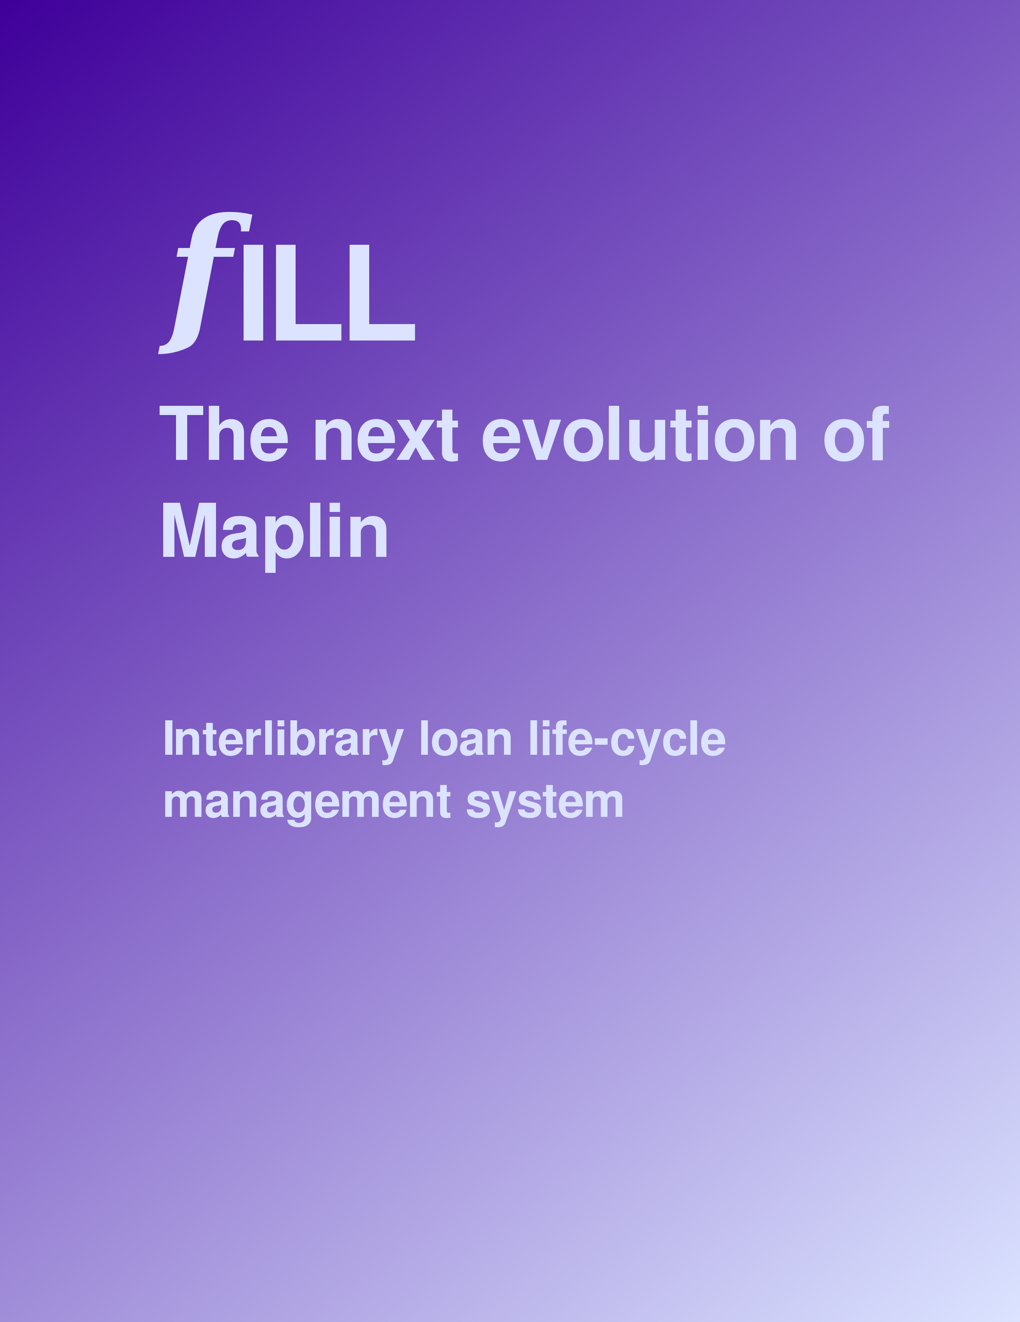
Table of Contents
fILL-osophy 3
Searching (a.k.a. “Resource Discovery”) 4
The layout of the Search screen 4
Search bar 4
Sorter 5
Search progress bar 5
Results 5
Refine 6
Requesting an ILL 6
ILL Life-cycle Management 7
Suggested daily processes 7
Requesting an Interlibray Loan 8
Making a request 8
Unfilled requests 8
When the books come in 8
Requesting a renewal / Checking status of Renewal requests 9
Returning the book to the lending library 9
Overdue items 9
Overrides 10
Filling interlibrary loan requests from other libraries 12
Pulling items from your shelves 12
Responding to interlibrary loan requests 12
Shipping 13
Responding to renewal requests 13
When the book comes back 13
Overrides 14
Working with lists 16
Example data table 16
“Disappearing” rows 16
You will always be able to find the request in the Current ILLs section (or History, after it's life cycle is complete), regardless of it's status. 17
Sorting the data 17
Searching within the data 18
You can keep copies of the data locally... if you really want to 18

fILL-osophy
For the last decade, Manitoba public libraries have been using a PLSB-developed resource discovery tool ("Maplin") to find Interlibrary Loan sources within the Manitoba public library community. The earliest version of Maplin was simply a union catalogue; as technology progressed and individual libraries' ILS systems gained Z39.50 server capabilities, Maplin became a Z39.50-based "distributed virtual union catalogue" - a single front-end which can find titles in any Manitoba public library and initiate an ILL request, via email.
This has worked well enough for resource discovery, but - as confirmed by a recent PLSB survey on ILL procedures - has led to each library (and sometimes each branch) developing their own procedures and workflows for handling the rest of the ILL life cycle. These run the gamut from custom-developed database systems to paper files; there is little consistency in procedures, the tracking of statistics is error-prone, and workloads can be heavy. One of Manitoba's unique challenges is balancing the capabilities of various ILS systems in the province to realize an effective discovery layer.
PLSB has developed the next evolution of Maplin - fILL - which incorporates full ILL life cycle management, following the structure set out in ISO 10161 (Interlibrary Loan Application Protocol Specification). This application, like Maplin-3, is a centrally-hosted system that requires nothing more than a Javascript-enabled web browser to use.
A key element in the design of fILL is simplicity. We want to make things as easy as possible on the beleaguered ILL staff of the libraries. All of the common functions necessary for dealing with the life cycle of an interlibrary loan - shipping, receiving, marking as unfilled, returning, requesting extensions, and finally marking an item as checked-in - can be done with a simple mouse click. Pull lists are sorted in call # order by default. Active or historical requests can be looked up by patron barcode, borrowing or lending library, title or author, date, or the status of the request. Requests can be easily (eventually automatically) forwarded to the next available source if a given library cannot fill it.
A second key element is adaptability. The system should be able fit relatively seamlessly into most existing workflows. And though most benefit will come from fully using fILL to manage all aspects of ILL, the system is not be dependent on every library fully participating.
The third key element is extensibility. The fILL prototype implements a subset of the ISO 10161 transactions; as need arises, this can be fleshed out to include more of the ISO standard. The system itself is Linux-based, uses common FOSS subsystems (Apache, PostgreSQL, the YAZ Z39.50 toolkit from Index Data), and is written in Perl and Javascript / jQuery. Because it is designed around the standard message types from ISO 10161, it should be relatively easy to have fILL emit and consume protocol messages to easily interact with any existing ILL management system that a library may have in place.
Our vision is smoother workflows, better statistics, reduced work load for the libraries, and an Interlibrary Loan system more responsive to the needs of our ultimate clients, the patrons.

Searching (a.k.a. “Resource Discovery”)

The layout of the Search screen (don't worry about the text on the screen here... we're just looking at how the screen is organized):

Search bar
You'll only see the search bar when you are in the “Borrowing from other libraries” -> “Search” area. It's up at the top so it doesn't take valuable screen real estate from the search results.
Keyword | The search bar gives you a simple, Google-like keyword search.
Title | To search for a specific title, use the following format:  ti=”10 little rubber ducks”
Author | To search for a specific author, use the following format:  au=”Carle, Eric”
Subject | To search for a specific subject, use the following format:  su=”ducks”

If you want to get really specific, you can combine any of the above as follows:
au="Carle, Eric" and su="Ducks"
...or even:
ducks and au="Carle, Eric"
(this one combines a keyword and an author search)
In general, though, you'll probably want to stick to the keyword search (it is not dependent on particular cataloguing practices of the various libraries, nor the capabilities of individual z39.50 servers).
If you only enter a few keywords, you'll get a long list of results... but you can always shorten that by refining the search (it's very fast).

Sorter
Search results are ordered by relevance. The underlying search technology has a complex relevance-ranking system that looks at the frequency of your search terms and the “importance” of the parts of the MARC record where those terms were found.
You can also sort in title order, or by publication date (ascending or descending).

Search progress bar
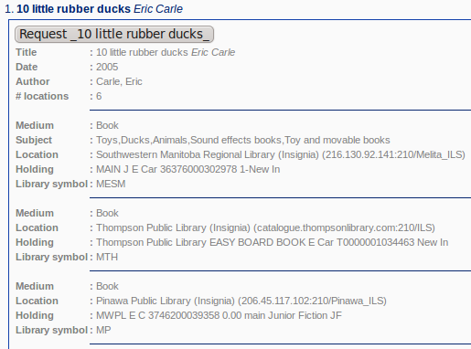
fILL begins displaying results as soon as they start coming in. You can start working with the results right away, but the results list will keep adding new results as long as libraries keep responding to the search.
As a rule-of-thumb, by the time the search progress bar is about 3/4 filled, most titles will already be in the results.

Results
Click on a title in the results list to show a button to request, as well as details about the title.
The top of the information shows the title, publication date, author, and # locations which report having it.
Below that is information specific to each holding library (the 'holding' line may or may not display item availability, depending on the what that library's z39.50 server returns).
You just need to click the button in order to make the request – all of the rest is just information if you're curious. (See the section of this guide on Making Requests for more information)

Refine
You can refine your search by selecting a term from the column along the left-hand side. These terms are collected from the results as they come in.
Clicking one of the terms will quickly re-do the search with the additional term added.

Requesting an ILL
We've already looked at the first steps:
- Go into “Requesting from another library” -> “Search”, and do your search.
- Click on the title in the results list.
- Click on the request button.
Here's what happens next:
- Enter your patron's barcode(or some other text that will identify, to you, who you are requesting for).
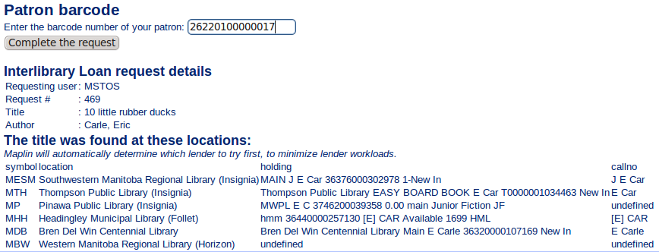
Again, the rest of the information displayed is just to satisfy your curiousity.
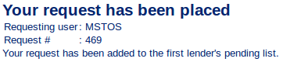
fILL will automatically choose the appropriate lender based on net-borrower/net-lender status. (We can adjust how fILL chooses, down the road, to take into consideration things like a library's open days, distance, etc., as was suggested at the Manitoba Libraries conference... for now, it's simply net-borrower/net-lender status).
That's it. You'll see that the request has been placed. The request is now handled by fILL's ILL life-cycle management.

ILL Life-cycle Management
Every library already manages the ILL life-cycle, whether that's through email folders, printing and filing, custom spreadsheets, or something completely different.
fILL will simplify this for you by tracking each request through each stage, with only a mouse-click or two from the lender and the borrower at each stage.
Patron asks
You search
and request
Lender sends
You receive
Patron reads
and returns
You return
Lender
checks in

Suggested daily processes
- Check for new requests from other libraries. You can do this at any time, as often as you want, by going to “Lending to other libraries” => “Pull list”. Print the list and pull the books, check them out in your ILS, and handle them in fILL (“Lending to other libraries” => “Respond”)
- Check for unfilled requests (requests which you have made that a lender could not fill), by going to “Borrowing from other libraries” => “Unfilled”
- Make requests of other libraries (however it suits your workflow – as the patron asks, during slower times, end of the day, first thing next morning, ....)
- When you ship, receive, return, or check in an ILL book, mark it in fILL.
The following pages give detailed, step-by-step instructions for each of the fILL menu options.

Requesting an Interlibray Loan

Making a request
Search for the book
Request the book. | - Click on the title to show the locations.  - Click the Request button.  - Enter your patron's barcode.  - Click the Complete the Request button.

Unfilled requests
Check for unfilled requests
Try next lender | If more potential lenders are available, there will be a Try next lender button.
Cancel request | If there are no further potential lenders (or you simply want to cancel the request), click the Cancel request button.

When the books come in
Receiving | 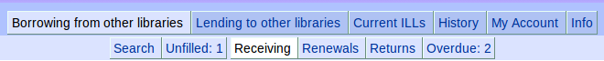
Choose slip printing | Click on one of Individual slips (default), Mulitple slips on a page, or Do not print slips. These are the date-due slips you can put in the book for your patron.
Receive the books | Click the Receive button for that book. If you have selected Individual slips, a date-due slip will be printed. If you have selected Multiple slips on a page, a button called Print now will appear under Printing of Date-Due Slips; you can click it at any time to print any accumulated slips (shown below the Receiving table).
Note | You do not need to create any kind of cataloguing record in your ILS. You will have access to your ILL request statistics through fILL.

Requesting a renewal / Checking status of Renewal requests
Renewals
Find the request | In the Search box (upper right), enter the patron's barcode number or some keywords from the title of the book you would like to renew. You can also sort the list by status, by clicking on the Status heading.
Ask for renewal | Click the Ask for renewal button. Your request will be added to the lending library's Renewal requests list.
Status of renewal request | The status column will show one of:  - Received (with an Ask for renewal button),  - Renew-Answer | Ok (with a new due date), or  - Renew-Answer | No-renewal (possibly with a message from the lender).

Returning the book to the lending library
As part of your ILL returns procedure
If you have a lot of ILLs to return | Enter some keywords from the title into the Search box (upper right)
Mark it as returned | Click the Return button.

Overdue items
Check for overdue items | 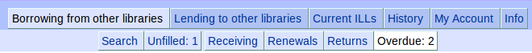

Overrides

If you receive a book but it is not in your Receiving list
The lender did not mark it as Shipped. | - Override this by going into Current ILLs => Current Borrowing.  - Click the + button in the Overrides column (right side) for that ILL.  - Click the Receive button.  - Proceed with When the book comes in, above.

If you get an overdue for a book you have returned
The lender did not mark it as Checked-in. | - Override this by going into Current ILLs => Current Borrowing.  - Click the + button in the Overrides column (right side) for that ILL.  - Click the Close button to close the ILL transaction. (The ILL gets moved to History)

Filling interlibrary loan requests from other libraries

Pulling items from your shelves
Show new requests
Suggested procedure | - Print entire pull list: click the Print button at the top of the list (formats the screen for printing), and then use your web browser's print function.  - Press the ESC (escape) key to exit the screen-printing format.  - As you pull books from the shelves, mark on the printed sheet any items you will not loan (and why). Standard reasons include:  - in use / on loan  - in process  - lost  - non-circulating  - not owned  - not on shelf  - on reserve  - poor condition  - charges (i.e. You are willing to loan it, but will charge a fee)  - on hold  - policy problem (e.g. too new, or don't loan this type of material, etc)  - other  - Proceed to Responding to interlibrary loan requests, below.
Notes | - You can check / print this list at any time. Any requests that you have not yet responded to will show up here.  - The list is in call # order by default. You can change the sort order by clicking on the various column headings.  - The list includes scannable patron barcodes for the requesting libraries (if you have entered these barcode numbers, taken from your ILS).

Responding to interlibrary loan requests
Send a response to the requesting library
Indicate whether you will fill the request or not | Click on either the Will-Supply button or the Unfilled button for each request.  - If you click Will-Supply, that request gets added to your Shipping list.  - If you click Unfilled, select a reason and click Submit.

Shipping
Shipping the item to the requestor
Check out in your ILS | Check out the items to the requesting libraries; note the due date.
Set a default due date | This will set the due date for all requests that you send. Set it to match the due date from your ILS. If you have different due dates for different types of items, set the default due date for one type and respond to all of those. Then change the default due date and respond to the rest.
Mark as sent | Find the item in the list, and click the Sent buton
Canada Post | Use the Canada Post library book shipping tool as usual.

Responding to renewal requests
List of renewal requests
Set a default due date | As in Responding to interlibrary loan requests, above.
Requests for which you will allow a renewal | - Click the Renew OK button.
Requests for which you will not allow a renewal | - Click the Can't renew button.  - [Optional] Enter a note to the requesting library.  - Click the Submit button.

When the book comes back
Close the ILL transaction | - Find the request and click the Check-in button. (The ILLgets moved to History)  - Then check the item in in your ILS.

Overrides

If the borrower has returned the book, but it is not in your Check-in list
The borrower did not mark it as Returned. | - Override this by going into Current ILLs => Current Lending.  - Click the + button in the Overrides column (right side) for that ILL.  - Click the Returned button.  - Proceed with When the book comes back, above.

Working with lists
fILL uses interactive data tables to present interlibrary loan information to you. These data tables enable you to sort and search through the data quickly and easily, save the data to your own computer, or format it for printing. Here's how:

Example data table
This example is taken from the Lending to other libraries => Respond section; other data tables will present different fields and actions that you can perform on a row (such as marking a requested item as Will-supply (or Unfilled) in this example).
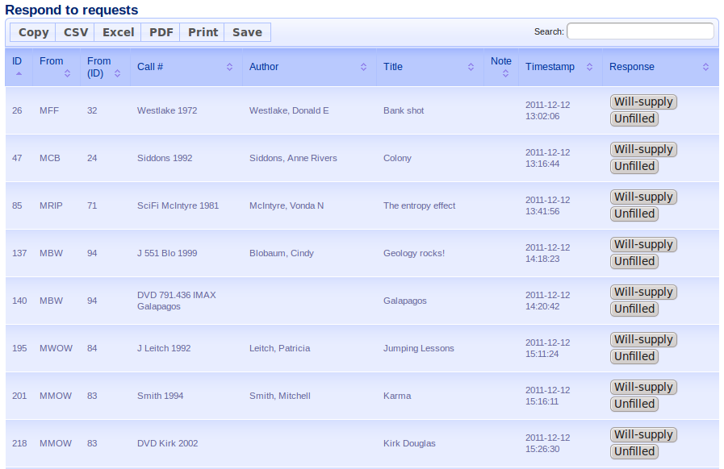

“Disappearing” rows
A quick note about the action buttons (usually in the right-most column): As you take actions, the rows may disappear from the table.
This is normal.
In the above example, if you click the Will-supply button for the title “Colony”, that request gets added to your shipping list, and is removed from the table of requests that are waiting for your response.

You will always be able to find the request in the Current ILLs section (or History, after it's life cycle is complete), regardless of it's status.

Sorting the data
You can sort a data table by clicking on the column heading for a column.
The example data table is sorted by timestamp. To sort by call #, click the word “Call #” in the heading:
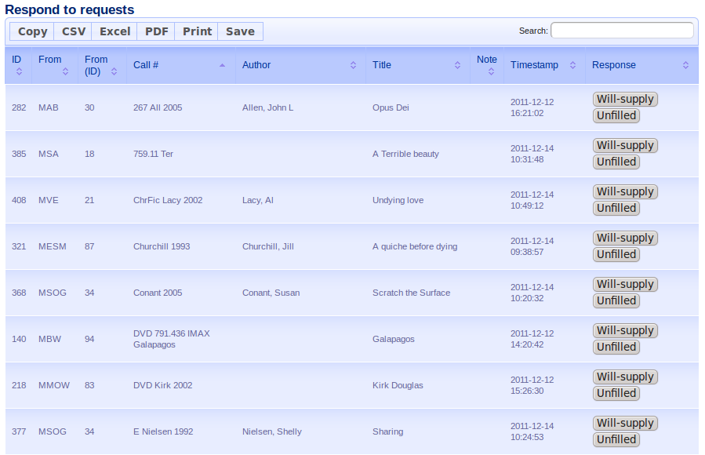
- Clicking it again will reverse the sort (in this case, reverse alphabetical order).
- You can sort by any column (some will make more sense than others), as often as you want.
- One current limitation is that you cannot sort by multiple columns at once.
- Sorting is very fast – the data table already has all of the data, and does not need to talk to the fILL server each time.

Searching within the data
The search box, in the upper right corner of the data table, is fast and powerful. It enables you to do a keyword search across all of the data in the table, and display only those rows that match.
For example, if you wanted to see which requests are from Border Regional's Virden branch (MVE), just enter 'mve' in the search box:
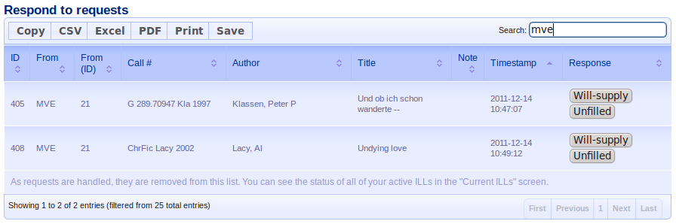
- The data table begins filtering as soon as you begin typing.
- Searching is not case sensitive (e.g. Searching for 'mmiow' will also match 'MMIOW')
- To get back to the complete table, just delete the text you've entered in the search box.
- Searching is very fast – the data table already has all of the data, and does not need to talk to the fILL server each time.
- You can combine searching and sorting. For example, if you typically handle ILL requests library-by-library, you could use 'search' to display the requests from a specific library, and then sort in call # order to make it easy to pull books from the shelves.
Some experimentation should let you figure out what works best with your workflows.

You can keep copies of the data locally... if you really want to

In the upper left corner of the data table is a set of buttons that enable you copy, save, and print the entire contents of the data table, if that suits your workflow.
- Copy: lets you paste the data into a document
- CSV: save the data as a comma-separated-value text file.
- Excel: save the data in Excel format.
- PDF: saves the data as a PDF (Adobe Acrobat) file
- Print: formats the data table for printing. Use the browser's print function to print it. Press ESC (escape) to return to the current view. (Note that while in the formatted-for-printing view, you can still sort by column, etc.)
fILL should handle all of the ILL tracking, statistics gathering work that makes up the bulk of the “ILL overhead” in terms of staff time. If you keep copies of the data locally for some ILL-management reason that fILL doesn't handle, let us know – if it makes ILL workflows easier for all libraries, we'll see about adding that functionality directly in fILL.

